Azure Kubernetes Service (AKS)

18 September 2022

16:12

**AKS Basics**

**What is Azure Kubernetes Service?**

Azure Kubernetes Service (AKS) simplifies deploying a managed Kubernetes cluster in Azure by offloading the operational overhead to Azure. As a hosted Kubernetes service, Azure handles critical tasks, like health monitoring and maintenance. Since Kubernetes masters are managed by Azure, you only manage and maintain the agent nodes. Thus, AKS is free; you only pay for the agent nodes within your clusters, not for the masters.

**AKS Cluster Architecture**

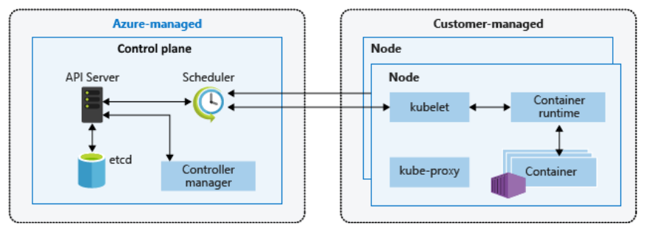

**Key Features**

* The fastest way to spin up managed Kubernetes clusters.
* Automated management and scalability of Kubernetes clusters for enterprise-grade container orchestration.
* End-to-end developer productivity with debugging, CI/CD, logging, and automated node maintenance.
* Advanced identity and access management to monitor and maintain container security for governance at scale.
* Support for Linux, Windows Server, and IoT resources with AKS deployment on the infrastructure of your choice using Azure Arc.
* Get flexible deployment options from the cloud to the edge with Azure Arc.

**AKS Pricing Tier**

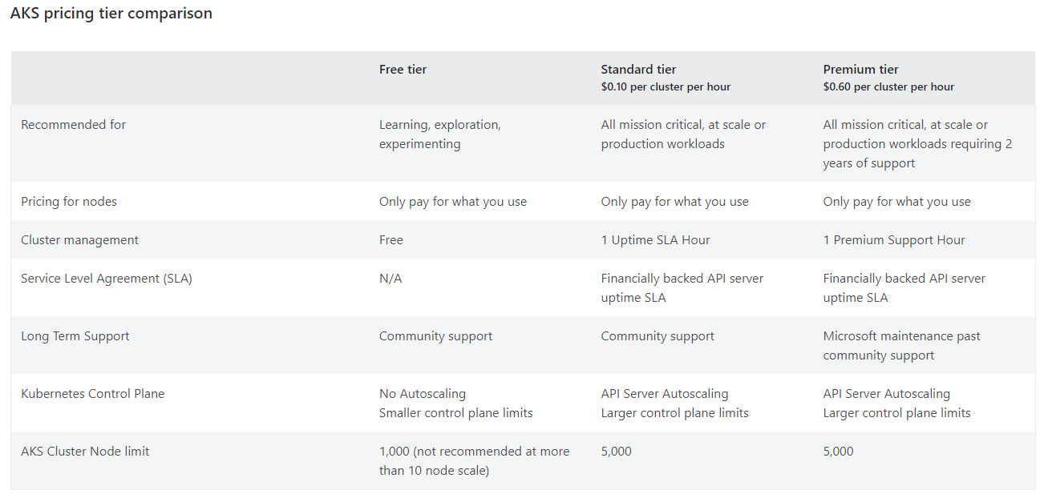

**MISC**

**---**